DNA barcoding and morphometric of Rastrelliger spp. in North Maluku Sea, Indonesia
Nebuchadnezzar Akbar^{1*}, Eko S Wibowo¹, Muhammad Irfan¹, M. Janib Achmad¹ , Iswandi Wahab², Yunita Ramili¹, Rustam E Paembonan¹, Abdurrachman Baksir¹, Irmalita Tahir¹, Firdaut Ismail¹, Najamuddin¹, Ikbal Marus¹, Abdul Ajiz Siolimbona¹ , Abdul Hamid A Toha³, Beginer Subhan⁴
¹Fisheries and Marine Faculty. Khairun University. Jl. Jusuf Abdulrahman, Ternate 97719, North Maluku. Indonesia.
² Fisheries and Marine Faculty.Pasifik University. Darame. South Morotai 97771. North Maluku. Indonesia.
³Department of Fisheries, Faculty of Fisheries and Marine Science, University of Papua (UNIPA). Manokwari 98314, West Papua, Indonesia.
⁴Department of Marine Science and Technology, Faculty of Fisheries and Marine Sciences, Bogor Agricultural University, Bogor, Indonesia.

ARTICEL INFO ABSTRACT

Keywords:
Biodiversity
Conservation
Ecology
Morphology
Species

Received: 19 June 2022
Accepted: 28 June 2022
Available online: 20 December 2022
DOI: 10.13170/ajas.7.3.25872
High exploration activity is feared to have an impact to mackerel populations. A sustainable management approach should be taken to provide information about the status of mackerel populations. Study of mackerel population status can be carried out through genetic information. The DNA of the fish samples were collected at traditional fish markets (Morotai, Bacan and Ternate). Laboratory works such as extraction, amplification, electrophoresis and DNA sequencing were analysis at the Indonesian Biodiversity Laboratory (Bionesia). The molecular characteristics of Rastrelliger kanagurta were 374 base pairs (bp). The composition of nucleotides showed the similarity of frequencies between species. Phylogenetic relationship of R. kanagurta in North Maluku Sea suggested that there was any differentiation. The genetic diversity of R. kanagurta was high with a total number of haplotypes and diverse nucleotide diversity. The minimum spawning networks (MSN) found 5 haplotype networks from a total of 12 samples. Morphological measurements of standard length, head height, body width, pectoral fin length and tail were found to have variable values. The length of the weight of the fish is obtained of b = 3, indicating that the growth pattern was isometric or weight gain was equivalent to the growth of the fish length.

Introduction
The waters of North Maluku situate between the two main entrances of Indonesian Throughflow (ITF). The water mass flows carrying a lot of nutrients through the Maluku Sea and Halmahera Sea (Hasanuddin, 1998). Therefore, this water mass flow provides benefits for North Maluku waters. Mackerel (Rastrelliger spp) is one of Ternate fisheries commodities with an average total production of more than 438 kg / month which is captured using a mini purse seine and gill net (Gill net) with fishing operation time with the average is 1-2 fishing operations per day (Tangke, 2014). The high activity of mackerel fishing has high relationship with the demand for people's consumption needs every day. Mackerel is a superior commodity that is used by the community for nutritional and protein needs. High exploration activity is feared to have an impact on the population. The process of catching activities carried out continuously will result in population decline and genetic variation in fish (Wigati et al., 2003). Tangke (2014) reported that mackerel caught by fishermen in the waters of Ternate City has a fast growth rate and high mortality rate, so generally mackerel caught is not yet spawned. This illustrates that the use of non-sustainable nature has been carried out, so that it has an impact on fish stocks. A sustainable management approach must be taken to provide information about the status of mackerel populations. Study of mackerel population status can be conducted through genetic information. This analysis aims to determine genetic diversity by looking at whether genetic movement occurs between populations so that it can determine the population's living status (Santos et al., 2010). Besides genetic diversity is an important information in the short and long term for a population (Ferguson et al., 1995).
Research on fish genetic in Indonesia has been carried out including genetic studies of large-eyed tuna populations (Thunnus obesus) in Benoa Bali (Nugraha, 2009), candra fish (Torsoro) originating from North Sumatra Province and West Java Province (Nugroho et al., 2006), red snapper (Lutjanus malabaricus) originating from several fishing areas of the North Coast of Java and the eastern Java Sea (Suwarso, 2002), yellowfin tuna (Thunnus albacores) from the regions of Bali, North Maluku and North Sulawesi (Permana et al., 2007), The similar study was also carried out by Wijaya et al. (2010) whose fish samples were taken from Spain and Philiphine, betutu fish originating from the Brebes weir reservoir (Susanto et al., 2006), Genetic Diversity in the Population of Beronang Fish (Siganus guttatus) in the Makassar Strait and Bone Bay using the random amplified polymorphic reservoir method DNA (Rapd) (Lante et al., 2011), a study of the structure of large-eyed tuna populations in the Indian Ocean, West Sumatra, South Java and Nusa Tenggara, conducted by Suman et al. (2013) and Akbar et al. (2014) on genetic diversity of yellowfin tuna from two populations in the Maluku sea, Indonesia, Akbar et al. (2020) on a preliminary study of the structure of the genetic population of yellow fin tuna from two populations in the Maluku sea, Indonesia, Molecular phylogenetic of grouper collecting from the traditional market (Jefri et al., 2015; Tapilatu et al., 2021; Dwifajri et al., 2022), Sardinella lemuru genetic variant in the strait waters Bali (Kartika et al., 2017) and genetic and phylogenetic variations of yellowfin tuna as a basis for sustainable fisheries management in North Maluku (Aris et al., 2017).
Since the information about mackerel genetic in North Maluku Sea especially around Morotai, Ternate and Bacan sea is not yet available. Even though this fish is a catch that has been available every day since ancient times. This is the reason why this work is essential to be done from genetic aspects. Beside, this study also provide the information on the genetic diversity which can indicate whether there is a genetic transfer between populations or not, so that, it can determine the population's life status of this pelagic species (Santos et al., 2010). Knowledge of genetic population structure is truly necessary in terms of the sustainability and effectiveness of resource management (Chiang et al., 2006; Chiang et al., 2008).

Materials and Methods
Sample collection
DNA samples were collected at traditional fish markets (Morotai, Bacan and Ternate). The number of samples found consisted of Morotai (n = 3), Bacan (n = 3) and Ternate (3 samples) (Figure 1). The samples were then taken the pictures, the 3 cm pectoral fins and so on putting in a tube containing 96% ethanol. Extraction, amplification, electrophoresis and sequencing were carried out in the Bionesia, Bali laboratory. While morphometric measurements of fish include standard length, head height, body width, pectoral fin length and tail.

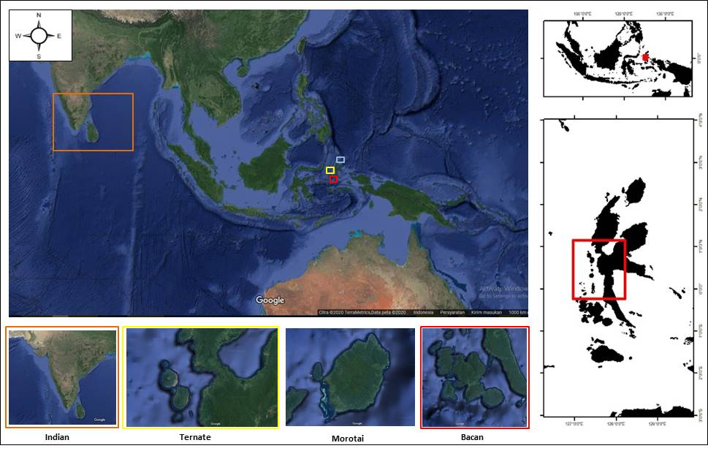
Figure 1. Research Sites R. kanagurta. Primer data (Ternate, Morotai and Bacan) and secondary data (Indian).

Extraction, amplification and electrophoresis DNA
Sample extraction was carried out using a Chelex 10% solution (Walsh et al., 1991). Tissue samples were taken of 2 mm using tweezers and inserted into a tube containing chelex solution. Before and after the tissue was removed, tweezers were dipped in 95% ethanol and burned with Bunsen flame. Chelex solution in which sample tissue has been inserted, were vortexed and centrifuged for 20 seconds, then heated in a heating block at a temperature of 95ºC for 45 minutes. After heating, the tube is returned to the vortex and centrifuge for 20 seconds. Extraction solution was ready to be used for amplification.
Sequencing
Samples that have been amplified by the PCR method were then sequenced at the sequencing service facility to obtain their nucleotide sequences, using the sanger sequencing method (Sanger et al., 1977).
Data analysis
Data analysis at the Indonesian Biodiversity laboratory (BIONESIA), Bali where the mtDNA region control sequence was analyzed using MEGA5 (Molecular Evolutionary Genetic Analysis) applications (Tamura et al., 2011), Arlequin 3.5 (Excoffier and Lischer, 2009), DnaSP 4.0 (Rozas et al., 2003) and Network 4.6. Secondary data was downloaded from GenBank (3 samples) with an accession number.
The length and weight relationship could be analyzed using the Linear Allometric Model (LAM) equation (Sparre and Venema, 1999) as follows.
W = (aL^{b})
Note: W is fish weight (gram), L is fish length (cm), a is linear regression intercept, b is regression coefficient. Value of b from the results of this calculation can reflect fish growth patterns. If the value of b = 3, then the growth pattern is isometric or weight gain is equivalent to the growth in length and if the value is ≠ 3, then the growth pattern is allometric. Allometric growth patterns are divided into two, namely positive allometric and negative allometric. If the value of b under 3 is called negative allometric (the length increase is faster than the weight gain), and if the value of b above 3 is called a positive allometric (the weight gain is faster than the length increase).

Results
Molecular characteristic
Molecular characteristics of male bloating (Rastrelliger kanagurta) in a total of 9 samples (Primary), 3 (Secondary) and 1 (out group) were found 374 base pairs (bp) in the locus control region of the mitochondrial DNA region (Table 4). DNA electrophoresis showed the success of the Polymerase Chain Reaction (PCR) stage (Figure 2). The appearance and color of the band shows a positive sign of the results of the extraction and PCR stages. The selection and use of primers and specific reagent components are appropriate, helping the success of electrophoresis. The quality of DNA tissue has an influence on the success of DNA analysis stages.
Genetic diversity
The genetic diversity of R. kanagurta was high with a total number of haplotypes and diverse nucleotide diversity (Table 6). Genetic diversity (Hd) and nucleotide diversity in Bacan (Hd = 0.0666 and Π = 0.006), Morotai (Hd = 0.0668 and Π = 0.006), Ternate (Hd = 0.0667 and Π = 0.006) and secondary Indian data (Hd = 0.0667 and Π = 0.002) (Table 3).
The minimum spawning networks (MSN) found 5 haplotype networks from a total of 12 samples (Figure 3). The haplotype network showed that there were 2 specific haplotypes, 8 haplotypes mixed between locations and the same 2 haplotypes (Figure 3). The distribution of the haplotype network showed that there was a relationship between the haplotype network and did not indicate grouping. The results of the analysis, which found high genetic diversity and specific haplotypes, gave a profile of the genetic structure of mackerel (R. kanagurta) populations.
Morphology characteristic
Sample collection at three locations found male mackerel (Rastrelliger kanagurta). Morphological measurements of mackerel at three locations were found to be of various sizes (Table 6). Morphological measurements of standard length, head height, body width, pectoral fin length and tail were found to have varying mean values ​​(Table 6). Such variations are due to the influence of age and sex.

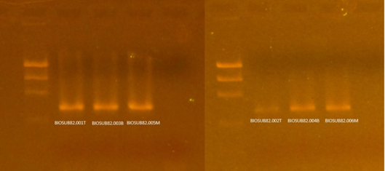
374 bp
Figure 2. Elektroforesis DNA Rastrelliger Spp.

Table 1. Sample, number of samples, base length (bp), location and source
Name | Samples Total | Base pairs (bp) | Location | Sources
Rastrelliger kanagurta | 9 | 374 | North Maluku Sea | -
Rastrelliger kanagurta | 342 | 1140 | Strait of Malacca (SSOM), South China Sea (SCS), Sulu Sea and Celebes Sea | Akib et al. (2015)
Rastrelliger kanagurta | 211 | 445 | Jawa Sea | Indaryanto et al. (2015)
Rastrelliger kanagurta | 24 | - | East Indonesia Sea | Zamroni et al. (2017)
Rastrelliger kanagurta | 30 | 154-220 | Andaman Sea | Munpholsri et al. (2013)
Rastrelliger kanagurta | 25 | 460 | Thailand, Cambodia, Madagascar dan Vietnam | Kielpinski et al. (2014)
Rastrelliger kanagurta | 53 | 1200 | West coast of Peninsular Malaysia | Darlina et al. (2011)
Rastrelliger kanagurta | 65 | - | India | Jayasankar et al. (2004)

Table 2. Number of samples, base pairs, species and sources.
No | Samples Total | Base pairs (bp) | Species | Sources
1 | 9 | 374 | Rastrelliger kanagurta | -
2 | 800 | 625 | Udang Sentadu | Barber et al. (2006)
3 | 280 | 860 | Bigeye Tuna | Chiang et al. (2008)
4 | 581 | 350 | Tuna Albacore | Davies et al. ( 2011)
5 | 18 | 792 | Walking Shark | Allen et al. (2013)
6 | 41 | 517 | Yellowfin Tuna | Akbar et al. (2014)
7 | 582 | 654 | Shark | Sembiring et al. (2014)
8 | 59 | 600 | Shark | Prehadi et al. (2015)
9 | 39 | 526 | Epinephelus spp | Jefri et al. (2015)
10 | 39 | 750 | Sarcophyton trocheliophorum | Kusuma et al. (2016)
11 | 179 | 656 | Turbinidae | Saleky et al. ( 2016)
12 | 72 | 512 | Yellowfin Tuna | Aris et al. (2017)
13 | 30 | 546 | skipjack | Akbar et al. (2018)
14 | 6 | 350 | Hemirhampus sp | Achmad et al. (2019)

Table 3. Genetic diversity analysis.
Locations | n | H_{n} | H_{d} | Π | Base Pairs
Bacan | 3 | 2 | 0.666 | 0.006 | 374
Morotai | 3 | 2 | 0.668 | 0.006 | 374
Ternate | 3 | 2 | 0.667 | 0.006 | 374
Indian | 3 | 2 | 0.667 | 0.002 | 374
n = number, Hn = Haplotype number, Hd= Haplotype diversity, Π = Nucleotide diversity

Table 4. Genetic diversity comparation between locations.
Locations | n | H_{n} | H_{d} | Π | Base Pairs
North Maluku (Bacan, Morotai, Ternate) | 9 | 4 | 0,639 | 0,005 | 347
Indian_GenBank | 3 | 2 | 0,0667 | 0,002 | 347
n = number, Hn = Haplotype number, Hd= Haplotype diversity, Π = Nucleotide diversity

Table 5. Genetic diversity comparation research result and marine organism other.
Species | Genetic Diversity | Literature
R. kanagurta | 0.666-0.668 | -
R. kanagurta | 0.972-1.000 | Akib et al. (2015)
R. kanagurta | 0.21-0.91 | Munpholsri et al. (2013)
R. kanagurta | 0.274-0.420 | Zamroni et al. (2017)
R. brachysoma | 0.000 | Zamroni et al. (2008)
Cromileptes altivelis | 0.774-0.794 | Sembiring et al. (2013)
T. Crocea, T. Maxima dan T. Squamosa | 0,480-1.000 | De Boer et al. (2014)
Tripneustes gratilla | 0.900 | Toha et al. (2014)
Sarcophyton trocheliophorum | 0.600-0.972 | Kusuma et al. (2016)
Turbinidae | 0.657-0.816 | Saleky et al. (2016)
T. albacares | 0.977-1.000 | Aris et al. (2017)
Katsuwonus pelamis | 0,800 – 0,995 | Akbar and Labenua (2018)
T. obesus | 0.996-1.000 | Akbar et al. (2018)
Hemiscyllium halmahera | 0.142-0.805 | Madduppa et al. (2020)

Table 6. Morphological characteristics of male mackerel (Rastrelliger kanagurta).
No | Morphology Characters (cm)
No | Location | Standar Length | Head Height | Head Length | Body Width | Pectoral Fin | Tail
1 | Bacan | 29 | 05.01 | 07.08 | 06.03 | 03.03 | 05.09
1 | Bacan | 30 | 05.02 | 07.09 | 06.05 | 03.04 | 6
2 | Morotai | 28 | 5 | 07.08 | 6 | 03.03 | 6
2 | Morotai | 29 | 5 | 07.08 | 06.03 | 03.03 | 05.09
3 | Ternate | 29 | 05.01 | 8 | 06.01 | 03.03 | 6
3 | Ternate | 28 | 5 | 07.08 | 06.01 | 03.02 | 05.09
Everages |  | 29 | 3 | 2 | 1 | 0 | 3

Table 7. Genetic diversity, population structure genetic and genetic distance catagories.
Catagory
Analysis | Low | Middle | High | Literature
Genetic diversity (H_{d}) | 0.1-0.4 | 0.5-0.7 | 0.8-1.00 | Nei, 1987
Amova population pairwaise (Fst) | 0.1-0.3 | 0.4-0.7 | 0.8-1.00 | Excoffier et al,1992
Genetic distance (D) | 0.010-0.099 | 0.1-0.99 | 1.00-2.00 | Nei, 1972

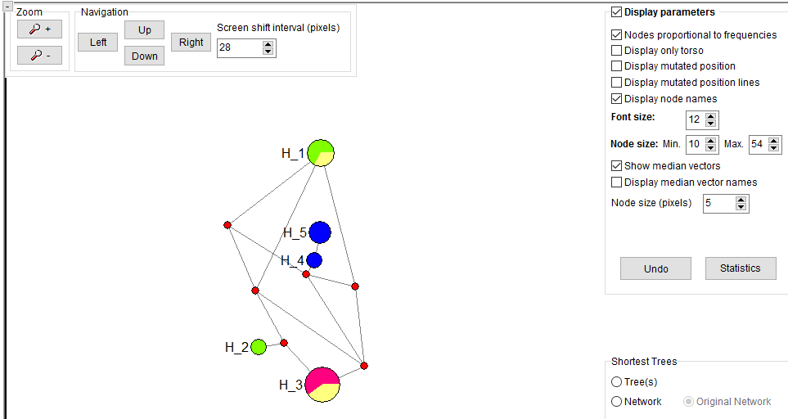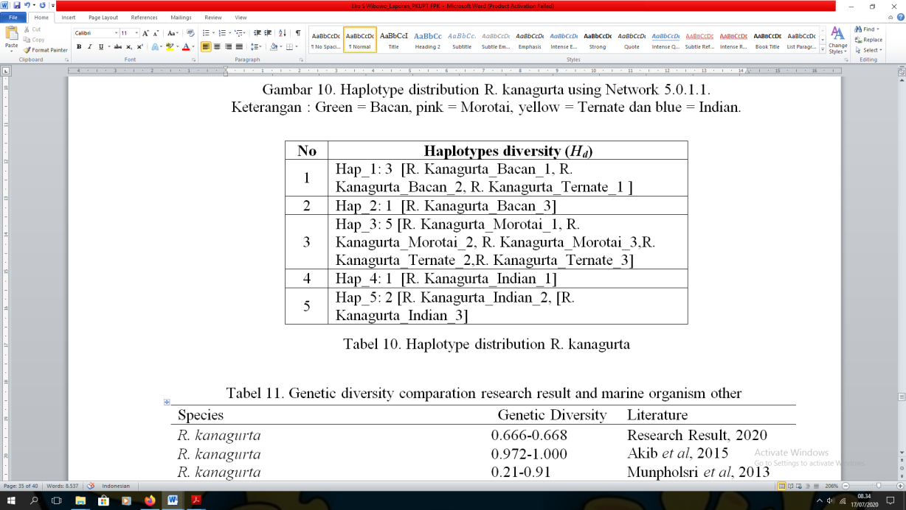
Figure 3. Haplotype distributions R. kanagurta using Network 5.0.1.1. Note. Green = Bacan, pink = Morotai, yellow = Ternate dan blue = Indian.

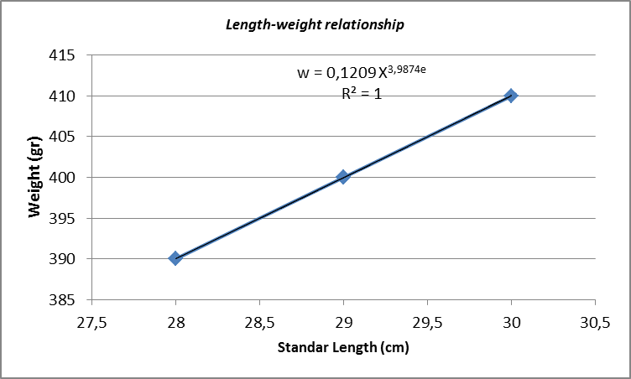
Figure 4. Length weight relationship R. kanagurta.

Fish populations have increased exploitation, sustainability strategies and sustainable use have to be taken into account so management and conservation are needed in this area. Calculation of mackerel (R. kanagurta) length and weight obtained by the coefficient of determination 1.00 which indicated that there was a weight gain of 100% which can be explained based on the regression other than the value of R2 greater than 1 which suggested a close relationship between the two variants.

Discussion
DNA isolation has an important role in the success of extraction of purification and quantity of DNA (Abdullah et al., 2019). The size of base pairs (bp) was the normal size of sea fish sequences, where the length of the base size in fish ranges from 200-1500 bp (Liu et al., 1999; Ali et al., 2004). Fragment length reported by Jayasankar et al. (2004), Darlina et al. (2011), Munpholsri et al. (2013), Kielpinski et al. (2014), Akib et al. (2015), Indaryanto et al. (2015) and Zamroni et al. (2017) (Table 1). Fragment length (bp) was found to be short compared to other studies (Table 1). The difference in base pair (bp) is due to the use of primers, PCR processes, contamination of organic matter, number of samples, DNA quality, primary specifics, primary base composition, environment, food and offspring, but do not show the effect of sequencing results (Williams et al., 1990 ; Shizuka and Lyon, 2008, Nuryanto and Kochzius, 2009; Akbar et al., 2014; Jefri et al., 2015; Saleky et al., 2016). The difference in base length can also be caused by the presence of nucleotide mutations and substitution in the genes of each species (Xio et al., 2007; Akbar et al., 2018). Length of DNA fragments of marine fish reported by Barber et al. (2006) found 625 bp in sentadu shrimp (stomatopoda), Chiang et al. (2008) with a length of 860 bp for large-eye tuna species, Davies et al. (2011) found 350 bp in albacore tuna, Allen et al. (2013) found 792 bp in walking sharks (Hemiscyllium halmahera), Akbar et al. (2014a) found 517 fragment length in yellow fin tuna, Prehadi et al. (2014) and Sembiring et al. (2015) obtained 600-700 bp from shark samples, Jefri et al. (2015) found 526 bp of the Epinephelus spp grouper species, Kusuma et al. (2016) i.e. 750 bp on Sarcophyton trocheliophorum soft corals, Saleky et al. (2016) obtained 656 bp in a turbinidae type gastropod, Aris et al. (2017) found 512 bp in yellow fin tuna, Akbar et al. (2018) obtained 546 bp in skipjack fish and Achmad et al. (2019) found 350 bp in Hemirhampus sp (Table 2). The difference in base pair in marine fish is due to variations in species, habitat and environmental adaptation (Martinez et al., 2018; Shuai et al., 2018). Pelagic fish are migratory and form different biological characteristics.
Comparison of R.kanagurta's genetic variability with other marine organisms such as Cromileptes altivelis, T. Crocea, T. Maxima and T. Squamosa, Tripneustes gratilla, Sarcophyton trocheliophorum, Sarcophyton trocheliophorum, Turbinidae, T. Maxima and T. Squamosa, Tripneustes gratilla, Sarcophyton trocheliophorum, Sarcophyton trocheliophorum, Turbinidae, T. Maxima and T. Squamosa, T. obesus and Hemiscium deer (Sembiring et al., 2015; Kusuma et al., 2016; Saleky et al., 2016; Aris et al., 2017; Akbar and Labenua, 2018; Akbar et al., 2018; Madduppa et al. , 2020) showed high genetic quality. The ability to migrate leads to high inter-population encounters and genetic diversity (Zardoya et al., 2004; Chiang et al., 2006;2008; Akbar et al., 2014; Akbar et al., 2018). The overall value of R. kanagurta's genetic diversity, when compared with other studies, was 0,000-1,000 (Table 10). Similarities and differences in the values of genetic diversity were due to differences in the number of samples used in the study (Akbar et al., 2014a). Nei (1987) said that the genetic diversity value of one species depends on the sample size found. Avise et al. (1989) stated that the overall haplotype diversity for mtDNA for some fish is in the range of 0.473-0.998. According to the genetic diversity criteria (Nei, 1987), the results of the study found illustrating that mackerel (R.kanagurta) has normal genetic diversity (Table 7). Even though this species was a target of conservation in each water, but with the ability to migrate and produce the fast tuna population can survive. Genetic diversity gives the ability to adapt to changes in the environment and climate and disease and showed the species has a large population size (Zamroni et al., 2017). is the main target species in fishing small pelagic fish categories, this is because this species is a fish that people consumption every day in North Maluku. High genetic diversity of mackerel (Rastrelliger sp.) reported by Akib et al. (2015) (Hd = 0.972-1000) in the Strait of Malacca (SOM), South China Sea (SCS), Sulu Sea and Celebes Sea, Munpholsri et al. (2013) (Hd = 0.21-0.91) in Andaman Sea, Thailand and Zamroni et al. (2017) (Hd = 0.274-0.420) in East Indonesia Sea (Table 4). Previous studies reported Zamroni et al. (2007) found low genetic diversity (Hd = 0,000) on the North coast of Java (Table 10). Zamroni et al. (2007) said that low genetic diversity was presumably that mackerel (R. brachysoma) originating from a population stock may also be spawning sites in the same area, this results in genetic introgression so that it showed low genetic diversity on the North coast of Java (Table 5).
Research on morphological characteristics in Indonesia reported by Telleng et al. (2010) in the waters of Buyat Bay, Suruwaky and Gunaisah (2013) Sorong sea waters, Tangke (2014) in the waters of North Maluku and Sonodihardjo and Yahya (2015) in the waters of Pancana, showed that there are no significant differences. Rastrelliger species have similar morphological characteristics despite different locations (Muchlisin et al., 2009; Indaryanto et al., 2015). Populations with high genetic closeness have morphological and genetic similarities as well as the environmental aspects (Kartika et al., 2017). Therefore, morphological studies are important in terms of the management and conservation of fisheries that are adequate for biodiversity and sustainability (Indaryanto et al., 2015). Morphological measurements of mackerel obtained in the standard size category. This illustrated that the mackerel population was still in normal condition, although the rate of catch utilization continues to increase. Zamroni et al. (2008) suggested that the existence of mackerel (Rastrelliger spp.) in the sea was captured using a mini purse seine in artisanal fisheries. Tangke (2014) suggested that mackerel in the waters of the island of Ternate has better growth than in the waters of the Java Sea, the Malacca Strait and the Jakarta Bay, allegedly related to the ecological factors of the habitat. The long weight relationship of fish needs to be known for the purposes of sustainable fisheries management. The management strategy is based on fish size data and information. Utilization rates that are not proportional to population growth in nature cause problems. The exponential graph of mackerel showed that there was a close relationship between individual weight and length (Figure 4).
The calculation results showed that 5.2646 was obtained, thus indicating that the value of b> 3. The length of the fish's weight has a value of b = 3, indicating that the growth pattern was isometric or weight gain is equivalent to the growth of the fish's length (Fuadi et al., 2016). Isometric growth patterns indicated that the population of mackerel (Rastrelliger kanagurta) in normal conditions. Although fishing operations were high so that it can threaten mackerel populations. The environment of sea on the islands of Morotai, Bacan and Ternate that has not been polluted (Marasabessy et al., 2010; Edward, 2015; Najamuddin et al., 2020), provides the opportunity for the presence of mackerel to make it a food area. Scientific approach was carried out such as reducing fishing effort in order to obtain maximum profit, but it still leads to fishing that is already large (Prahadina et al., 2015). The results obtained were different from the Suruwaky and Gunaisah report (2015) which found that the resources of mackerel (Rastrelliger kanagurta) at Sorong sea waters have been over exploited so that allometric growth was negative. Tangke (2014) found mackerel caught in the coastal waters of Ternate Island has a fast growth rate and a high mortality rate, where generally caught by fishermen are mackerel size 14.90 which was the size of fish that have not yet performed spawning but it could also be seen that the rate of mackerel exploitation in Ternate island's coastal waters have more catch with an E value of 0.54. Male bloating fisheries in Barru Regency waters have experienced more capture (Sonodihardjo and Yahya, 2015). Indian mackerel (Rastrelliger kanagurta) in Thailand has experienced a decline in catch over the past few years and has been identified as overexploitation (Munpholsri et al., 2013).

Conclusions
Molecular characteristics of male bloating (R.kanagurta) in a total of 9 samples (Primary), 3 (Secondary) and 1 (out group) were found 374 base pairs (bp) in the locus control region of the mitochondrial DNA region. The results of the study found to describe that mackerel (R.kanagurta) has normal genetic diversity. The minimum spawning networks (MSN) found 5 haplotype networks from a total of 12 samples. The distribution of haplotype networks showed that there was a relationship between haplotype networks and did not show grouping. High polymorphism increased the ability of populations in disturbed environments. Morphological measurements of standard length, head height, body width, pectoral fin length and tail were investigated to have varying mean values. Isometric growth patterns indicated that the population of mackerel (R.kanagurta) in normal conditions.

Acknowledgments
The author would like to thank the Khairun University for granting the 2020 research grant funding through the Fisheries and Marine Science Faculty research program.

References

Abdisa, T., R. Hasen, T. Tagesu, G. Regea, G. Tadese. 2019. Poultry coccidiosis and its prevention, control. Journal of Veterinary and Animal Research 1, (1):1-6.
Abdullah, A., H. A. Sativa, T. Nurhayati, M. Nurilmala. 2019. Utilization of DNA barcodes for traceability of labels of various commercial surimi-based processed fish products. Jurnal Pengolahan Hasil Perikanan Indonesia, 22(3): 508-519.
Achmad, M.J., M. Djamhur, M. A. Fabanyo, N. Akbar. 2019. DNA barcoding application of garfish (Hemirhampus sp.) in North Maluku Sea. Journal of ichthyology of Indonesia,19(3) : 463-473.
Akbar, N., N. P. Zamani, H. H. Madduppa. 2014. Genetic diversity of yellowfin tuna (Thunnus albacares) from two populations in the Maluku Sea, Indonesia. Depik, 3(1): 65-73.
Aris, M., N. Akbar, R. Labenua. 2017. Genetic and phylogenetic variations of yellowfin tuna (Thunnus albacares) as a basis for sustainable fishery resources management in North Moluccas. International Journal of Pharmacy and Biological Sciences, 8(4):419-426.
Akbar, N., M. Aris, M. Irfan, I. Tahir, A. Baksir, Surahman, H. H. Madduppa, R. Kotta. 2018. Phylogenetic of tuna fish (Thunnus spp.) in North Mollucas Sea, Indonesia. Indonesian Journal of Ichthyology, 18(1): 1-11.
Akbar, N., R. Labenua. 2018. Genetic diversity of skipjack (Katsuwonus pelamis) in North Maluku Sea. Depik, 7(2):164-176.
Akbar, N., M. Irfan, M. Aris. 2018. Population Genetics and Phylogeography of Bigeye Tuna in Moluccas Seas, Indonesia. Indonesian Journal of Marine Sciences, 23(4):145-155
Akib, N. A. M., M. B. Tam, P. Phumee, M. Z. Abidin, S. Tamadoni, P. B. Mather, S. A. M. Nor. 2015. High connectivity in Rastrelliger kanagurta: influence of historical signatures and migratory behaviour inferred from mtDNA Cytochrome b. PLoS ONE, 10(3): e0119749.
Allen, G. R., M. V. Erdmann, C. L. Dudgeon.2013. Hemiscyllium halmahera, a new species of Bamboo Shark (Hemiscylliidae) from Indonesia. International Journal of Ichthyology, 19(3): 123-136.
Avise, J. C., B. W. Bowen, T. Lamp. 1989. DNA fingerprint from hypervariable mitochondrial genotypes. Molecular Biology Evolution, 6: 258-269.
Barber, P. H., M. V. Erdmann, S. R. Palumbi.2006. Comparative phylogeography of three codistributed Stomatopods: origins and timing of regional lineage diversification in the coral triangle. Journal Evolution, 60(9):1825-1839.
Chiang, H. C., C. C. Hsu, H. D. Lin, G. C. Ma, T. Y. Chiang, H. Y. 2006. Population structure of Bigeye tuna (Thunnus obesus) in the South China Sea, Philippine Sea and western Pacific Ocean inferred from mitochondrial DNA. Fisheries Reserch, 79: 219- 225.
Chiang, H. C., C. C. Hsu, G. C. C. Wu, S. K. Chang, H. Y.2008. Population structure of bigeye tuna (Thunnus obesus) in the Indian Ocean Inferred From Mitochondrial DNA. Fisheries Research, 90: 305-312.
Darlina, M. N., A. R. Masazurah, P. Jayakansar, A. F. J. Samsari, A. M. N. Siti.2011. Morphometric and molecular analysis of mackerel (Rastrelliger spp.) from the west coast of Peninsular Malaysia. Genetics and Molecular Research, 10(3): 2078-2092
Davies, C. A., E. M. Gosling, A. Was, D. Brophy, N. Tysklind. 2011. Microsatellite analysis of albacore tuna (Thunnus alalunga): population genetic structure in the North-East Atlantic Ocean and Mediterranean Sea. Marine Biology, 158: 2727-2740.
Dwifajri, S., R. F. Tapilatu, B. Pranata, A. B. Kusuma. 2022. Molecular phylogeny of grouper of Ephinephelus genus in Jayapura, Papua, Indonesia, inferred from cytochrome oxidase I (COI) Gene. Biodiversitas, 23(3):1449-1456
Edward. 2015. Evaluation on heavy metals pollution in sediment in Morotai Island waters, North of Maluku. Depik, 4(2): 95-106 Exoffier, L., P. E. Smouse, Quattro, J. M. 1992. Analysis of moleculer variance inferred from metric distance among DNA haplotypes; application to human mitochondrial DNA restriction data. Genetics, 131: 479-491.
Excoffier, L., H. Lischer. 2009. Arlequin ver 3.5 user manual ; an integrated software package for population genetics data analysis. Swiss Institute of Bioinformatics Graham CA, Hill AJM. 2001. DNA Sequencing Protocols Second Edition. Humana Press. Totowa, New Jersey.
FAO. 1974. FAO species identification sheets for fisheries purpose. Food and Agriculture Organization of United Nation. Rome. Fakhri, F., I. Narayani, I. G. N. K. Mahardika. 2015. Genetic diversity of Skipjack tuna (Katsuwonus pelamis) from Jembrana and Karangasem, Bali. Jurnal Biologi, 19 (1):11-14.
Ferguson, A., Taggart, T. B. Prodohl, O. McMeel, C. Thompson, C. Stone, P. McGinnity, R. A. Hynes.1995. The application of moleculer markers to study and conservation of fish population, with special reference to Salmo. Journal of Fish Biology, 47:103- 126.
Indaryanto, F. R., H. Imai, Y. Wardiatno. 2015. Genetic variation of short body Mackerel, Rastrelliger brachysoma of Jawa Island, Indonesia Based on mtDNA Control Region Sequences. AACL Bioflux 8, (5):648-655.
Jayasankar, P., P. C. Thomas, M. P. Paulton, J. Mathew. 2004. Morphometric and genetic analyzes of indian Mackerel (Rastrelliger kanagurta) from Peninsular India. Asian Fisheries Science, 17:201- 215.
Jefri, E., N. P. Zamani, B. Subhan, H. H. Madduppa. 2015. Molecular phylogeny inferred from mitochondrial DNA of the Grouper epinephelus spp. In Indonesia collected from local fish market. Biodiversitas, 16(2):254-263.
Kartika, G. R. A., A. Sartimbul, Widodo. 2017. Genetic variance of Sardinela Lemuru in the Bali Strait Waters. Indonesian Journal of Marine Science and Technology, 10(1):21- 28.
Kielpinski, M., J. Kempter, R. Panicz, S. Keszka. 2014. Genetic identifiability of selected populations of indian Mackerel, Rastrelliger kanagurta (Actinopterygii: Perciformes: Scombridae)- Celfish Project-Part 1. Acta Ichthyologica et Piscatoria, 44(2): 145-152.
Kusuma, A., D. G. Bengen, H. H. Madduppa, B. Subhan, D. Arafat, B. F. S. P. Negara. 2016. Close genetic connectivity of soft coral Sarcophyton trocheliophorum in Indonesia and its implication for marine protected area. Aceh Journal of Animal Science, 1 (2):50-57.
Lante, S., A. Tenriulo, A. Parenrengi, Rachmansyah, A. C. Malina. 2011. The genetic diversity of the Baronang fish (Siganus guttatus) population in the Makassar Strait and Bone Bay using the random amplified polymorphic method random amplified polymorphic DNA (RAPD). Jurnal Riset Akuakultur, 6(2):211- 224.
Liu, Z. J., P. Li, B. J. Argue, R. A. Dunham. 1999. Random amplified polymorphic DNA markers: usefulness for gene mapping and analysis of genetic variation of catfish. Aquaculture, 174:59-68.
Madduppa, H. H., A. S. P. Putri, R. Z. Wicaksono, B, Subhan, N. Akbar, F. Ismail, D. Arafat, D. Prabuning, L. M. I. Sani, E. S. Srimariana, A. Baksir, D. G. Bengen. 2020. Morphometric and DNA Barcoding of endemic Halmaheran walking shark (Hemiscyllium halmahera, Allen, 2013) in North Maluku, Indonesia. Biodiversitas, 21(7):3331-3343.
Marasabessy, M.D., Edward, F. L. Valentin.2010. Monitoring of heavy metal levels in sea and sediments in Bacan Island, North Maluku. Makara Sains, 14(1):32-38.
Martinez, S.A., J. R. Willoughby, M. R. Christie.2018. Genetic diversity in fishes is influenced by habitat type and life history variation. Ecology Evolution, 8(23):12022-12031.
Munpholsri, N., S. Poompuang, W . Senanan, W . Kamonrat.2013. Microsatellite markers suggested moderate genetic variation in indian Mackerel (Rastrelliger kanagurta) populations from the Andaman Sea, Thailand. Kasetsart Journal-Natural Science, 47: 853-863.
Muchlisin, Z. A., A. R. Masazurah, T. A. Abu, A. M. N. Siti, B. Samsudin, A. F. J. Jamsari. 2009. Genetic identification of four Malaysian mackerel species off coast of Peninsular Malaysia based on molecular marker. In: 8th Malaysia Genetic Congress: Role of Genetics in Wealth Creation and Quality of Life , 4–6 August 2009, Awana Genting, Pahang, Malaysia, pp. 74-77.
Najamuddin., I. K. Kasim, A. Baksir, R. E. Paembonan, I. Tahir, M. R. Lessy. 2020. Water quality and pollution status in coastal water of Ternate City. Jurnal Ilmu Kelautan Kepulauan, 3(1): 35-45.
Nei, M. 1972. Genetic distance between population. American Nature, 106:283-292.
Nei, M. 1987. Moleculer evolutionary genetics. New York. Columbia University. Press. New York.
Nuryanto, A., M. Kochzius. 2009. Highly restricted gene flow and deep evolutionary lineages in the giant clam Tridacna maxima. Coral Reefs, 28:607-619.
Nugroho, E., J. Subagja, S. Asih, T. Kurniasih. 2006. Genetic diversity evaluation Tor with marker mtDNA D-loop and Random Amplified Polymorphism DNA (RAPD). Jurnal Riset Akuakultur, 1(2):211-217.
Nugraha, B. 2009. Study on genetics of bigeye tuna (Thunnus obesus) populations catching longline tuna landed in Benoa. Thesis. Bogor, Graduate program. Bogor Agricultural University, Bogor.
Permana, G. N., J. H. Hutapea, Haryanti, S. B. M. Sembiring.2007. Genetic variation of yellowfin tuna (Thunnus albaceras) by allozyme and mtDNA electrophoresis analysis. Jurnal Riset Akuakultur, 2 (1): 41-50.
Prahadina, V. D.,Boer, M.,; Fahrudin, A. 2015. Resources of Indian Mackerel (Rastrelliger kanagurta Cuvier 1817) in Sunda Strait water that landed on PPP Labuan, Banten. Marine Fisheries, 6(2 ): 169- 175.
Prehadi., A. Sembiring, A. M. Kurniasih, Rahmad, D. Arafat, B. Subhan, H. H. Madduppa. 2014. DNA barcoding and phylogenetic reconstruction of shark species landed in Muncar fisheries landing site in comparison with Southern Java fishing port. Biodiversitas, 16(1): 55-61.
Rozas, J., J. C. Sanchez-DeI Barrio, Messeguer, R. X. Rozas. 2003. DnaSP, DNA polymorphism analyses by the coalescent and other methods. Bioinformatics, 19: 2496-2497.
Saleky, D., I. Setyobudiandi, H. A. Toha, M. Takdir, H. H. Madduppa. 2016. Length-weight relationship and population genetic of two marine gastropods species (Turbinidae: Turbo sparverius and Turbo bruneus) in the Bird Seascape Papua, Indonesia. Biodiversitas, 17(1): 208-217.
Sanger, F., S. Nicklen, A. R. Coulson. 1977. DNA sequencing with chain-terminating inhibitors. National Academical Science, United Stated of America, 74(12): 5463-5467.
Santos, M. D., G. V. Lopez, N. C. Barut. 2010. A pilot study on the genetic variation of Eastern Little Tuna (Euthynnus affinis) in Southeast Asia. Philippine Journal of Science, 139(1): 43-50.
Sembiring, A., N. P. D. Pertiwi, A. Mahardini, R. Wulandari, E. M. Kurniasih, A. W. Kuncoro, N. K. D. Cahyani, A. W. Anggoro, M. Ulfa, H. H. Madduppa, K. E. Carpenter, P. H. Barber, I. G. N. Mahardika. 2015. DNA barcoding reveals targeted fisheries for endangered sharks in Indonesia. Fisheries Research, 164: 130- 134.
Shui, F., S. Yu, S. Lek, X. Li. 2018. Habitat effects on intraspecies variation in functional morphology: Evidence from freshwater fish. Ecology Evolution, 8(22):10902-10913.
Shizuka, D., B. E. Lyon. 2008. Improving the reliability of molecular sexing using a W-specific marker. Molecular Ecology Resources, 8: 1249-1253.
Sonodihardjo, A. S., M. A. Yahya.2015. Structure population of Indian Mackerel, Rastrelliger kanagurta Catch in Pancana Waters, Barru District. Jurnal Galung Tropika, 4(1):42-49.
Suman, A., H. E. Irianto, K. Amri, B. Nugraha. 2013. Population structure and reproduction of bigeye tuna (Thunnus obesus) in Indian ocean at western part of Sumatera and southern part of Java and Nusa Tenggara. Indian Ocean Tuna Commission, 8 Oktober 2013. 1-14 pages.
Susanto, A. H., S. Suryaningsih. 2006. Biochimecal variation genetic Oxyeleotris marmorata (Oxyeleotris marmorata. BLKR) in reservoir Penjalin Brebes. Jurnal Biota, 11(3):136-141.
Suruwaky, A. M., E. Gunaisah.2013. Identification of the exploitation level of male pufferfish (Rastrelliger kanagurta) in terms of length and weight relationship. Jurnal Akuatika, 4(2):131-140.
Suwarso. 2002. Geographic variation in population structure Lutjanus malabaricus (Lutjanidae) and enviromental interaction in Jawa Sea. Thesis. Bogor, Graduate program. Bogor Agricultural University, Bogor.
Tamura, K., D. Peterson, N. Peterson, G. Stecher, M. Nei, S. Kumar. 2011. MEGA5: Molecular evolutionary genetics analysis using maximum likehood, evolutionary distance and maximum parsimony method. Moleculer Biology Evolution, 28(10):2731- 2739.
Tangke, U. 2014. Monitoring the dynamic parameters of the mackerel (Rastrelliger sp) population in the coastal waters of Ternate Island, North Maluku Province. Jurnal Ilmiah Agribisnis dan Perikanan, 7(2): 8-14.
Tapilatu, R. F., T. S. Tururaja, Sipriyadi, A. B. Kusuma. 2021. Molecular phylogeny reconstruction of grouper (Serranidae: Epinephelinae) at Northern Part of Bird’s Head Seascape-Papua inferred from COI gene. Fisheries and Aquatic Sciences, 24(5):181-190.
Telleng, A. T. R. 2010. Indian Mackerel (Rastrelliger sp.) fisheries on Buyat bay. Jurnal Teknologi Perikanan dan Kelautan, 10(1):51-59. Toha, A. H. A., R. Binur, Suhaemi, Lutfi, Hakim, Luchman, N.
Widodo, S. B. Sumitro.2014. Genetic aspects of the commercially used sea Urchin Tripneustes gratilla. A review. Journal of Biological Research, 20:12-17.
Walsh, P. S., D. A. Metzger, R. Higuchi. 1991. Chelex-100 as a medium for simple extraction of DNA for PCR based typing from forensic material. Biotechniques, 10:506-513.
Williams, J. G. K., A. R. Kubelik, K. J. Livak, J. A. Rafalski, S. V. Tingey. 1990. DNA polymorphism amplified by arbitrary primers are useful as genetic markers. Nucleic Acids Research, 18:6531- 6535.
Zamroni, A., Suwarso, N. A. Mukhlis. 2008. Reproduction biology and population genetic Mackarel (Rastrelliger brachysoma, Famili Scombridae) in north Jawa coastal. Jurnal Penelitian Perikanan Indonesia, 14(2):215-226.
Zamroni, A., Suwarso, A. Kuswoyo.2017. Genetic variation of Indian Mackerel, Rastrelliger kanagurta (Cuvier, 1817) in the waters of Eastern Indonesia. Bawal, 9(2):123-131.
Zardoya, R., R. Castilho, C. Grande, L. Favre-Krey, S. Caetano, S. Marcato, G. Krey, T. Patarnello. 2004. Differential population structuring of two closely related fish species, the mackerel (Scomber scombrus) and the chub mackerel (Scomber japonicus), in the Mediterranean Sea. Molecular Ecology, 13:1785-1798.

