
Riwayat: Educational Journal of History and Humanities, 6 (1), 2023, pp. 169-180

P-ISSN: 2614-3917, E-ISSN: 2775-5037
DOI: https://doi.org/10.24815/jr.v6i1.29515

Mind Mapping Strategy in Improving Students’ Writing Skill in Politeknik Unggul LP3M Medan
Hermansyah
Accounting Study Program, Politeknik Unggul LP3M Medan. Indonesia
Corresponding Author: hermansyahlmb@gmail.com
Article history
Received : 2022-08-21
Accepted : 2022-09-08
Published : 2023-01-14

Abstract: The research objectives are to find out the differences in writing skill between students who write essays with mind mapping, and the conventional and the effectiveness of mind mapping in improving students’ writing skill in the 2nd semester of accounting study program at Politeknik Unggul LP3M. The research applied Pretest-Posttest Control Group Design. Two out of three classes of population were selected as the research sample randomly namely class AK-AP2A/21 as the control group, and class AK-AP2B/21 as the experimental group. The research instrument used was essay writing assessment sheet. The validity of the research instrument was content validity and the reliability was calculated by using Cronbach’s Alpha internal consistency technique. The research results show a significant difference in writing essays between students in the experimental group and in the control group. It is indicated by the t-test calculation for the independent sample in the form of a t-count score is greater than the t-table score (t_{c}=5.506 > t_{t}= 1.990) at a 5% level of significance with70 df. The other research result shows writing essays using mind mapping is more effective than the conventional one. It is indicated by the results of the t-test for paired samples which show that the t-score (t_{c}) is 14,636 with 35 df. The t-count score is consulted with the t-table value at a 5% level of significance with 35 df. The t-table score (t_{t}) at 5% level of significance with 35 df is 2.031. It shows that the t-count score is greater than the t-table score (t_{c} =14,636 > t_{t} = 2,031).
Keywords:
Mind Mapping, Language Skills, Writing Essays


Abstrak: Penelitian ini bertujuan untuk mengetahui perbedaan kemampuan menulis antara mahasiswa yang belajar menulis esai dengan menggunakan mind mapping dan dengan cara yang konvensional. Selain itu tujuan penelitian ini adalah untuk mengetahui keefektifan mind mapping dalam meningkatkan kemampuan menulis mahasiswa semester 2 program studi Akuntansi, Politeknik Unggul LP3M Medan. Penelitian ini menggunakan desain Pretest – Posttest Control Group Design dan 2 dari 3 kelas dari total populasi dipilih sebagai sampel penelitian yang secara acak yaitu kelas AK-AP2A/21 sebagai kelompok kontrol, dan kelas AK-AP2B/21 sebagai kelompok eksperimen. Instrumen penelitian yang digunakan adalah lembar penilaian menulis esai. Validitas instrumen penelitian adalah validitas isi dan reliabilitas dihitung dengan menggunakan teknik konsistensi internal Cronbach’s Alpha. Hasil penelitian menunjukkan adanya perbedaan yang signifikan dalam kemampuan menulis esai antara siswa kelompok eksperimen dan kelompok kontrol. Hal ini ditunjukkan dengan perhitungan uji-t sampel bebas berupa skor t-hitung lebih besar dari skor t-tabel (t_{h} = 5,506 > t_{t} = 1,990) pada taraf signifikansi 5% dan db 70. Hasil lainnya dari penelitian ini menunjukkan bahwa menulis esai dengan menggunakan strategi mind mapping lebih efektif dari cara yang konvensional. Hal tersebut ditunjukkan dengan hasil uji-t untuk sampel berhubungan yang menunjukkan nilai t-hitung (t_{h}) sebesar 14,636
Available online at http://jurnal.unsyiah.ac.id/riwayat/

dengan db 35. Nilai t-hitung dikon-sultasikan dengan nilai t-tabel pada taraf signifikansi 5% dan db 35. Nilai t_{t} pada taraf signifikansi 5% dan db 35 adalah 2,031. Hal ini menun-jukkan bahwa nilai t_{h} lebih besar dari nilai t_{t} (t_{h} =14,636 > t_{t} =2,031).
INTRODUCTION
Four language skills include speaking, reading, listening, and writing. The four aspects of language skills are closely related to other lang-uage skills. If one aspect of the skills has a problem, it will affect the other language skills. Writing skill plays an important role in developing language proficiency. Beca-use the students' ideas can be captured and assessed and criti-cized by readers through writing activities. The other words, writing can be defined as an acti-vity of transferring or delivering ideas, thoughts, and feel-ings to the readers.
Although it has been realized that mastery of written language is absolute in education and life, in fact the teaching of writing is getting less attention. The lecturers do not pay attention to the stu-dents' ability and interest in writing essays. It can have already been imagi-ned the results obtained and the skills possessed by students that cause low learning outcomes.
In the aspect of teaching essay writing, a lecturer must think creatively and actively therefore students can have writing skill in an appropriate language standard and correct spelling. So far, lecturers have only relied on the lectu-re's conventional method and giving writing assignments by giving titles or themes that have been determi-ned from time to time. There is no outline of an essay and no explanation of good writing which makes the lesson seems very boring.
The monotonous learning process makes students less motivated to engage in writing activities. In fact, Variations of learning English can attract students to be active in writing essays. The learning pro-cess applied must be in accordance with the material and characteristics of students, therefore the learning runs optimally.
One of the variations in learning to write essays is by using a mind mapping strategy. It can help students to plan and organize a piece of writing. Mind mapp-ing strategy is a learning method based on how the brain works. It is called strategy or method because the mind mapping in the form of systematic steps is like a map. It plans the steps of activities that will be carried out by students before the writing activity. Mind Mapping is also a great route map for our memories, and enables us to structure facts and thoughts in such a way (Tony Buzon, 2007:4-5). The other words, by using the mind mapping strategy, memorizing information will be easier and more reliable than using traditional recording techniques.
Applying mind mapping in learning method is expected to be able to help students in writing activities. Admitted-ly, the mind mapping strategy has not been used frequently by either lecturers or students. Besides not yet familiar too, the steps of this mind mapping have not been fully understood. Based on the observation, what the researcher did as an English lecturer, and information from the other English lecturers at Politeknik Unggul LP3M Medan, the low achievement in learning English for the students of accounting study program in the 2nd semester is caused by a lack of mastery of writing skills.
Based on the explanation above the researcher took the initiative to use mind mapping learning methods and writing skills. The teaching method is expected to be more effective and help students in writing skill.
Based on the background of the study, the researcher initiates to conduct a study entitles “Mind Mapping Strategy in Improving Students’ Writing Skill in Politek-nik Unggul LP3M Medan". In this study, the researcher tried to do rese-arch activities in teaching English, especially in writing essays in the 2nd semester by applying the mind mapping method in writing essays.
From the description of the back-ground above, the objectives of this research is to find out whether any diffe-rences in writing skill between students who study to write essays with mind mapping and the conventional one. The other objective is to find out the effect-tiveness of mind mapping in improving students’ writing skill.
METHOD
This experimental research applied Pretest-Posttest Control Group Design. Two out of three classes of the total population in the 2nd semester of Acco-unting study program at Politeknik Unggul LP3M in academic year 2021/ 2022 were selected as the research sample randomly namely 30 students in class AK-AP2A/21 as the control group, and 30 students in class AK-AP2B/21 as the experimental group. Sugiyono (2010: 113) suggests that in this design the selection of experimental and control group is done randomly. Then the experimental and control group were given a pre-test. The pre-test is conduc-ted to find out whether there is differ-rence on the first state between both groups.
The instrument used in this research is a writing assessment sheet which refers to the writing assignment model with an interval scale that has been adapted to the characteristics of essays. The research instrument in the form of assessment guidelines for writ-ing essays is declared valid and can be used after being consulted with the researcher’ former thesis super-visor and the reliability of the research instrument in this study used Cronbach's Alpha internal consistency technique. The assessment sheets of writing essays gives grades on a scale. Therefore, Cron-bach's Alpha internal consistency tech-nique is used to test instruments with scaled answers.
r = _ k 1- σi²
k-1 σ²
Remarks:
r: The coefficient reliability which is sought
k: Number of questions
σ²: Variance of test scores
σi²: Variance of questions
The variance of questions can be obtained by using the following formula
σi² = $σi=\frac{\sum{X_{i}^{2}}-\frac{(\sum{X{i)}^{2}}}{N}}{N}$
Remarks:
∑i² : Variance of questions to “n” (e.g: the 1st question, the 2nd question an on …)
∑X_{i} : Number of scores of the answers to number of the questions to “n”

The reliability test in the form of a test instrument was tested in class AK-AP2C/21 which is a class outside of the experimental group and the control group. Furthermore, these results were analyzed using the SPSS ver. 27.0. The results of the reliability test obtained a coefficient value of alpha=0.700 which was greater than 0.6. therefore it is stated reliable.
In collecting data analysis, the students was given a test in the form of writing essays, therefore data is obtain-ned in the form of students’ writing test results. Then the collected data is analyzed by using t-test statistics for related samples to test the effectiveness of mind mapping to write essays in the experimental group. The t-test statistical formula for related samples is as follows (Nurgiyantoro, 2009b: 183).
Remarks:
S² : Variance of population
N₁,N₂ : Number of subjects in the 1st and 2nd sample groups
X₁,X₂ : Average score of the 1st and 2nd sample groups.

The results of t-test toward the related sample are shown by the calcu-lation of the t-test in the Paired Samples Test table. The magnitude of the calcu-lated t value in the Paired table Samples Test is shown by number in line t with a significance level of 5% (0.05).
This research uses the t-test statistic for independent samples carry out the analysis because the t-test for independent samples is a statistical technique to test whether there is a difference between the groups tested. The t-test statistical formula for indepen-dent samples is as follows (Nurgi yantoro, 2009b: 190).
$t= \frac{\sum{D}}{\frac{(N D)^{2}-{\left( D\right)}^{2}}{N-1}}$

Remarks:
ΣD : Sum of differences between each pair (X₁-X₂ = D)
N : Sum of the subject of the research
The result of the independent sample t-test using SPSS version 27.0 is shown by calculating the t-test in the Independent Samples t-table. The ma-gnitude of the calculated t-value in the Independent Samples Test table is indi-cated by the number in the t row with a 5% level of significance.
The result of normality test calcu-lations with the help of SPSS version 27.0 is indicated by the magnitude of the numbers in the Kolmogorov-Smirnov Z line. The data is will be normally distributed if the Kolmogorov-Smirnov Z value is greater than the 5% level of significance.
The homogeneity test of variance is intended to determine whether the population variance of each group is ho-mogeneous or not significantly different. To test the homogeneity of the variances, it is necessary to carry out a statistical test (test of variance) on the score distribution of the groups concerned, the formula used is as follows (Nurgi-yantoro, 2009b: 216).
F = s²b
s²k
s²b : Greater variance
s²k : Smaller variance

The calculation results with SPSS version 27.0 are shown by the One-way results in the Test of Homogeneity of Variances table. The data will be homo-geneous if the significance value in the Test of Homogeneity of Variances table is greater than 5% level of significance.
RESULT AND DISCUSSION
Result
Results of the Pre-test
A pre-test was carried out in the form of an essay writing test. Subjects in the pre-test were 30 students each in class AK-AP2A/21 as control group and in class AK-AP3B/21 as experimental group. The results of the pre-test in writing essays for control group presen-ted in table 1. By using SPSS version 27.0, it is known that the average score (mean) in the pre-test was 63; mode by 60; mid score (median) 63; and the standard deviation is 6.697. It can be seen in the table below
Table 1. The Frequency of Pre-test Result in Writing Essay For the Control Group

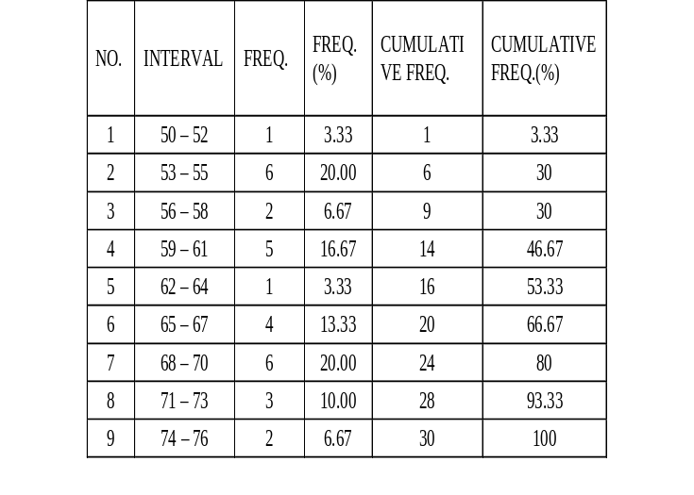
Meanwhile, results of the pre-test in writing essay for experimental group can be seen in table 2. By using SPSS ver.27.0, it was found that the average score (mean) in the pre-test was 62.44; mode by 60; middle score (median) 61.50; and the standard deviation is 5.368.
Table 2. The Frequency of the Pre-test Result in Writing Essay For Experimental Group

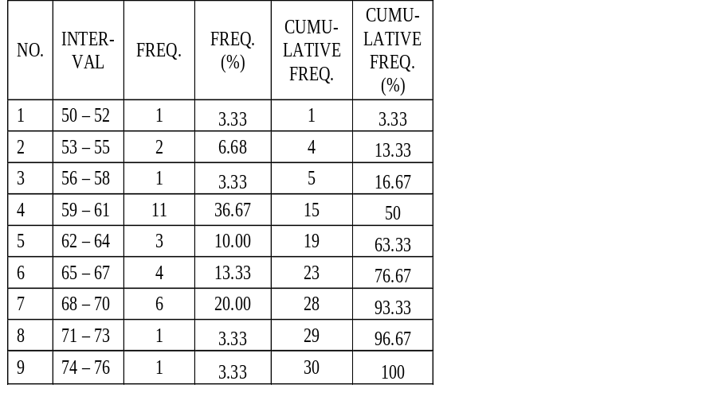
Results of the Post-test
From the results of post-test in the essay writing test for the control & experi-mental can be seen in table 3 and 4. By using SPSS version 27.0, it was found that the average score (mean) achieved by students in the control group during the post-test was 71.97; mode by 70; mid score (median) 73; and the standard deviation is 6.420.
Table 3. The Frequency of Post-test Result in Writing Essay For the Control Group

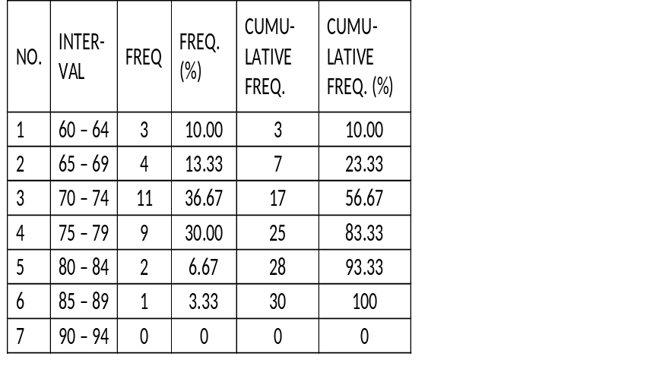
Meanwhile, results of the post-test essay writing test for experiemental group by using SPSS version 27.0, found that the average score (mean) was 79.97; mode by 80; mid score (median) 80; and the standard deviation is 5.896.
Table 4. The Frequency of Post-test Result in Writing Essay For the Experimental Group

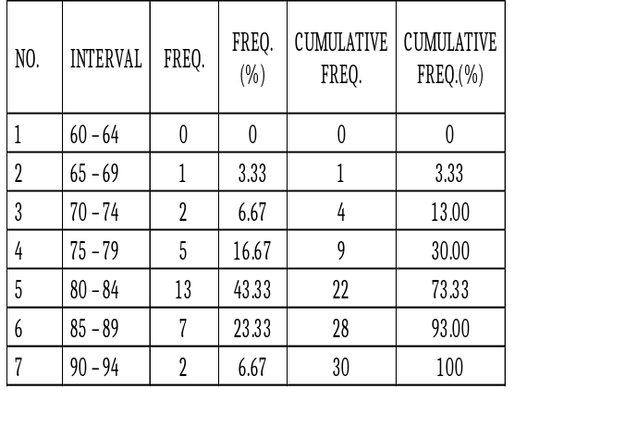
After having the research, the summary of the descriptive statistical analysis of the pre-test and post-test scores for the control and experimental group is presented in the table 5.
Table 5. Statistical Data Comparison of Pre-test and Post-test Scores for the Control Group and the Experimental Group

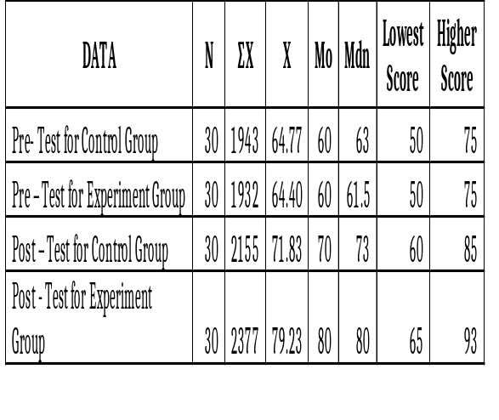
From table 5 above, the average score (mean) between the pre-test and post-test scores of the control group and the experimental group has increased. During the pre-test, the average score for the control group was 64.77, while the average score during the post-test was 71.83. The average score of the control group increased by 7.07. The average score of the experimental group at the pre-test was 64.40, while at the post-test it was 79.23. The average score of the experimental group increased by 14.83.
Based on the explanation above, it can be concluded that the increase in the average score of the experimental group is greater than the increase in the average score of the control group. The difference in the mean scores of the two groups was 7.77
Testing Data Analysis Requirements
After analyzing the data, the data analysis requirements were first tested which consisted of the normality test of data distribution and the homogeneity of variance test. The summary of the results of the normality test for the distribution of data on the essay writing results of the two group and is presented in table 6 as follows.
Table 6: Summary of Results of the Normality Test for Distribution of Essay Writing Data

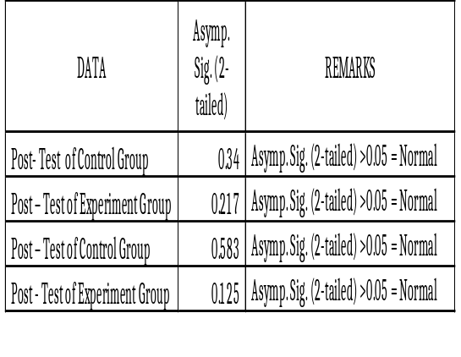
The results of the calculation of the normality test of data distribution are known to be Asymp values. Sig. (2-tailed) is greater than 0.05 (5%). It can be concluded that the distribution of pre-test and post-test data for writing essays in the control group and the experi-mental group is normally distributed. Meanwhile the terms of the variance of the data are said to be homogeneous if the significance value of the calculated results is greater than the specified degree of significance, namely 0.05.
Table 7. Summary of Data Homogeneity of Pretest and Posttest Result

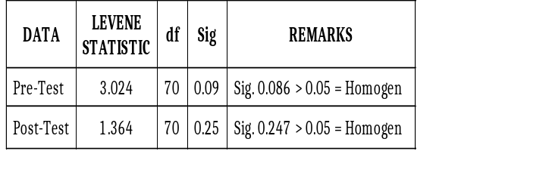
Through the results of calculating the homogeneity test of variance of the pre-test data, it can be seen that the score of Levene's test results is 3.024, with 70 df, and a signi-ficance of 0.086. Because the significance is greater than 0.05, the essay writing pretest data in this study has a homogeneous variance or does not have a different variance. Through the results of calculating the homogeneity test of variance of the post-test data, it can be seen that the score of Levene's test results is 1.364, with 70 df, and a significance of 0.247. Because the signi-ficance is greater than 0.05, the post-test essay writing data in this study has a homogeneous variance or does not have a different variance. From the summary above, it can be seen that the variance of the pre-test and post-test data for essay writing is homogeneous.
Data Analysis
This data analysis aims to find out differences in essay writing skills bet-ween groups that take lessons using mind mapping with groups that follow conventional learning as well as the effecttiveness of using mind mapping in writing essays. The following are the results of data analysis using the t-test.
a. Paired Sample T-Test
Calculation of the t-test for paired samples was carried out with SPSS ver-sion 27.0. Data requirements are signi-ficant if t-count (t_{c}) is greater than t-table (t_{t}).
- The pre-test and post-test data of writing essays for the control group

The t-test carried out on the pre-test and the post-test data of the control group is to find out the difference in the students’ writing skill between before and after treatment. The summary of the results of the t-test for the pre-test and post-test data for the control group is as follows.
Table 8: Summary of t-test Results on Pretest and Posttest Data of Writing Essays for Control Group

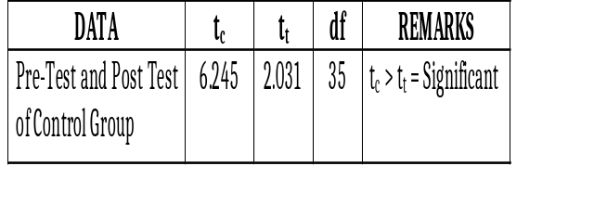
From table 8 above, it can be seen that the t count (t_{c}) is 6.245 with 35 df. Then, the t count score is consulted with the t table value at a 5% level of significance with 35 df. T- table score (t_{t}) at a 5% level of significance with 35 df is 2.031. This shows that t-count score is greater than the t-table score (t_{c} = 6.245 > t_{t} = 2.031). Thus, the results of the t-test showed that there were differences in the essay writing skills of the control group students between before and after learning.

- The pre-test and post-test data in writing of Experimental group in writing essays

The t-test was carried out on the pre-test and post-test data of the experimental group is to find out the differences in students' essay writing skills between before and after treat-ment. This is to prove the effectiveness of using mind mapping in learning to write essays.
Table 9: Summary of the Pre-test and Post-Test Data Results in Writing Essays for the Experimental Group.

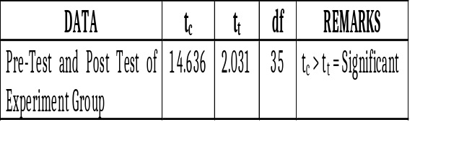
From table 9 above, it can be seen that the t-count (t_{c}) is 14.636 with 35 db. Then, the t-count score is consulted with the t-table value at a 5% level of signifi-cance with 35 df. T table score (t_{t}) at a 5% level of significance with 35 df is 2.031. This shows that the calculated t-count is greater than the t-table score (t_{c} = 14.636 > t_{t} = 2.031). Thus, the results of the t-test showed that there was a significant difference between the students' essay writing skills in the experi-mental group before and after treatment using mind mapping. Based on the explanation above, the use of mind mapping is effect-tively used in learning to write essays.
b. Independent Sample t-test
Calculation of the t-test for inde-pendent samples was carried out with the help of the SPSS version 27.0 to test differences in essay writing skills bet-ween the experimental group which took part in learning using mind mapp-ing and the control group which took part in conventional learning. Data require-ments are significant if t-count (t_{c}) is greater than t- table (t_{t}).
- Pre-test Data of Writing Essay for Control Group and Experimental Group
The t-test was conducted to determine whether there were different abilities to write essays between the con-trol group and the experimental group.
Table 10: Summary of t-test results of Pre-test Data

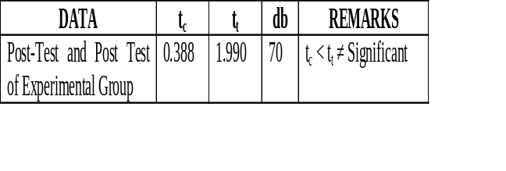
From table 10 above, it can be seen that the t count (t_{c}) is 0.388 with 70 db. Then, the t count score is consulted with the t table value at a significance level of 5% and 70 db. T table score (t_{t}) at a significance level of 5 % and db 70 is 1.990. This shows that the calculated t score is smaller than the t table score (t_{c} = 0.388 < t_{t} = 1.990). Thus, the results of the t-test showed that there was no different ability in the pre-condition to write essays between the control group and the experimental group.
2) Post-test data in writing essays
The t-test was conducted on the post-test essay writing data of the control group and the experimental group post-test was carried out to deter-mine whether there were differences in essay writing skills after being given treatment between the control group and the experimental group. The sum-mary of the results of the post-test t-test data writing essays in the control group and the experimental group is as follows.
Table 11: Summary of Post-test Data T-test Results Writing Essays Control Group and Experiment Group

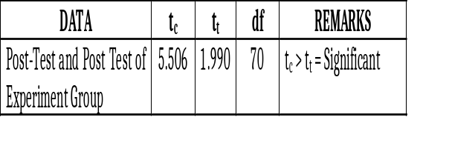
From table 11 above, it can be seen that the t count (t_{c}) is 5.506 with 70 db. Then, the t count score is consulted with the t table value at a significance level of 5% and 70 db. t-table score (t_{t}) at a significance level of 5 % and db 70 is 1.990. This shows that the calculated t score is greater than the t table score (t_{c} = 5.506 > t_{t} = 1.990). Thus, the results of the t-test showed that there was a significant difference between the essay writing skills of the control group and the experimental group after being given treatment.
Discussion
This research applied Pretest– Posttest Control Group Design. Two out of three classes of the total population in the 2nd semester of Accounting study program at Politeknik Unggul LP3M in academic year 2021/2022 were selected as the research sample randomly. There are 30 students each in class AK-AP2A/ 21 as the control group, and in class AK-AP2B/21 as the experimental group. The objectives of this research were to determine differences in essay writing skills between groups that used mind mapping strategy in teaching essay writing and groups that followed con-ventional learning, as well as to find out the effectiveness of using mind mapping in writing essay.
1. Description of the Pre-Conditions of Essay Writing Skills
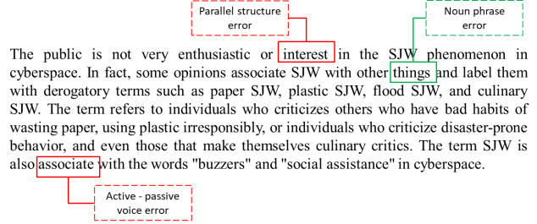
The pre-conditions of the two groups were known by doing a pre-test writing essay. Researcher collected data using research instruments in the form of essay writing assessment guidelines. From the results of the data collection, the pre-test scores of the control group and the experimental group were obtained. From these results it can be seen that the essay writing test scores of the control group and the experimental group were still low. The development of paragraphs in writing essay is still far from being good. The development of paragraphs in a substandard essay can be seen from the explanatory sentences in the paragraphs that are not in accordance with the main sentence, so the paragraphs become less logical. There is more than one main idea in a paragraph. There are some grammartical errors in the use of conjuctions, word forms, subject – verb agreement, verb tenses, parallel structre, relative pronoun, gerund and noun prhases. It can be seen in the following paragraph.
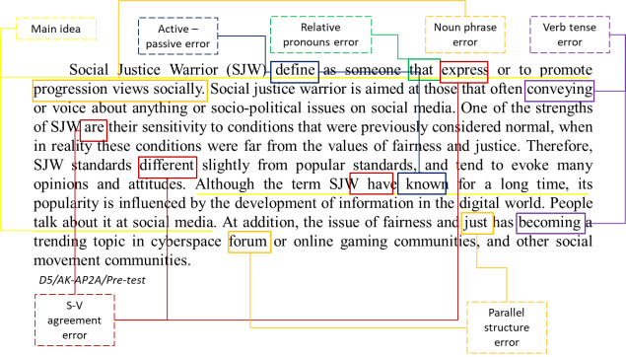
Figure 1. Description of the Pre-Conditions of Essay Writing Skills
In general, both control group and experimental group have the same low writing skills in writing essay at the pre- condition.
2. Description of the Post-Conditions of Essay Writing Skills
From the results of the data collection, the post-test scores of the control group and the experimental group were obtained. Based on the research data results show that the test scores in writing essays for the two groups increased. Furthermore, students’ essay writing in the experimental group during the post-test had an increase in the content, grammar and organization aspects. However, there are still some errors in the mechanical aspects of the essay. An example of essay written by the students in experimental group is as follows.
Figure 2. Description of the Post-Conditions of Essay Writing Skills

Essays writing during the post-test by the control group also experienced an increase, but not as significant as in the experimental group. The ideas in the paragraph are not well developed. There is no further explanation or presentation of evidence that can strengthen the counter statements in the paragraph above. In addition, there are also errors in the mechanical aspect, grammar, inappropriate ideas, and the choice of words used.
3. Differences in Essay Writing Skills
After the two groups were considered the same, then each group was given treatment. Students in experimental group were treaten to write essays by using mind mapping. Students who use mind mapping can develop their mind ideas, concepts and facts in learning material to write essays conducted by lecturer. After learning to write essays by using mind mapping, the experimental group had a fairly high increase, while students in the control group who took part in conventional essay writing lessons had a less increase than the experimental group. This can be seen from the average score during the pre-test and post-test of writing essays in the control group. Thus, the results of the t-test showed that there were differences in the skills of writing essays after being given treatment between the control group and the experimental group.
The success of learning to write essays using mind mapping can be linked to the theory according to Buzan (2011: 98) that mind mapping is the only tool that can be relied upon to help think expansively and creatively when one needs to generate ideas, plan something uniquely, or excite the imagination. The successful use of mind mapping technique is also in accordance with Wycoff's theory (in Hernowo, 2005: 141) that mind mapping is a good way to generate and organize ideas before starting to write.
The results of the research in the experimental group show that the use of mind mapping has been proven to be beneficial for students in writing essays so that there is an increase in writing skills. The benefits obtained by students in the experimental group are indicated by several things, including the organization of ideas that are more well organized, so that essay writing does not go off topic, the development of paragraphs produced by students looks more logical, and the delivery of supporting evidence is more convincing.
From the statement above it is obvious that there are differences in essay writing skills between the group that take part in learning using mind mapping and the group that take part in conventional learning. This shows that the objective of this research has been achieved.
4. Effectiveness of Using Mind Mapping in Writing Essays
The effectiveness of using mind mapping in learning to write essays in the experimental group is known by the t-test formula for related samples. Based on the SPSS Version 27.0 calculation results, it can be seen that the value of t-count (t_{c}) is 14.636 with 35 df. Then, the t-count score is consulted with the t-table value at a significance level of 5% with 35 df. The t-table score (t_{t}) is at a 5% level of significance with 35 df is 2.031. This shows that the calculation of t-count score is greater than the t table score (t_{c} = 14.636 > t_{t} = 2.031). Thus, the results of the t-test indicate that the use of mind mapping is effectively used in writing essays.
The results of research for the experimental group show that the use of mind mapping has been proven to be effective in improving essay writing skills. The mind mapping helps students to organize their ideas, thought, evidence, and facts to write an essay. Thus, students can plan to writing an essay well. As stated by Silberman (2011: 200) that through making mind mapping, students will find it easy to identify what they have learned and what will be planned clearly and creatively. Sagala (2009: 74) states that mind mapping is a teaching approach that provides opportunities for students to participate in the process of discovery or preparation of a concept as a process skill. Students in the experimental group became more active in learning to write essays. The mind mapping that has been compiled then becomes a reference during the process of writing essays, so that the essays that are written do not go out of the topic. Buzan (2011: 184) states that mind mapping not only helps plan what to write, but is also useful when developing them in writing. The enthusiasm of the student in experimental group to compile a mind mapping was quite high. The preparation of mind mapping is more interesting for students in writing essays. The use of mind mapping involves student creativity, so that learning is not monotonous and boring. Students can plan an essay by compiling a mind mapping based on each idea and the ideas accompanied by pictures and using colors. As stated by Hernacki and Bobbi (2002: 172) that there are several advantages of mind mapping, namely (1) flexibility, (2) being able to focus attention, (3) increasing understanding, and (4) fun. Basen on this research discussion, it can be stated the use of mind mapping is effectively used in learning to write essays.
CONCLUSION
The conclusion of this research can be drawn as follows: (a) There is a significant difference in writing essays between students in the experimental group and students in the control group. It is indicated by the t-test calculation for the free sample in the form of a t-count score is greater than the t-table score (t_{c} = 5.506 > t_{t} = 1.990) at a 5% level of significance with 70 df. (b) Writing essays using mind mapping is more effective than the conventional one. It is indicated by the results of the t-test for related samples which show that the t-score (t_{c}) is 14,636 with db 35. The t-count score is consulted with the t-table value at a 5% of significance and with 35 df. The t-table score (t_{t}) ) at a 5% level of significance with 35 df is 2.031. It shows that the t-count score is greater than the t-table score (t_{c} = 14,636 > t_{t} = 2,031).
SUGGESTION
The use of mind mapping strategy in writing essays can assist students in planning ideas before they are compiled into essays, so that the essays they make become more organized. In addition, it becomes a guide for students to carry out writing activities.

REFERENCES
Buzan, Tony. (2011). Buku Pintar Mind Map. Jakarta: PT. Gramedia Pustaka Utama.https://www.academia.edu /25766471/Buku_Pintar_Mind_Map_Tony_Buzan
Dianti, I. L., & Rosaline, N. (2022). The Influence of Individual Characteristics, Work Placement and Work Environment on Employee Performance at CV. Enam Jaya. 5(2), 434–442.
Gie, The Liang. (2002). Terampil Menga-rang. Yogyakarta: Andi Publisher. Retrieved from https:// onesearch. id/Record/IOS3318.YOGYA-02090000055239
Hernacki, Mike dan Bobbi Deporter. (2002). Quantum Learning. Bandung: PT. Mizan Pustaka.
https://books.google.co.id /books?id=6_Nx2_6T2cAC&printsec=frontcover&hl=id#v=onepage&q&f=false
Hernowo. (2005). Quantum Writing. Bandung: MLC. Retrieved from https://adoc.pub/-book-quantum-writing-pdf-by-hernowo-ebook-or-kindle-epub-fr.html
Malekzadeh, Bahareh. (2015). The Effect of Mind Mapping Strategy on Comprehending Implicit Information in EFL Reading Texts. International Journal of Educational Investigations. Retrieved from
http://www.ijeionline.com/attachments/article/40/IJEIonline_Vol.2_No.3_2015-3-09.pdf
Nursisto. (1999). Penuntun Mengarang. Yogyakarta: Adicita.
https://opac.perpusnas.go.id/DetailOpac.aspx?id=346039
Nurgiyantoro, Burhan. (2009a). Penilaian Otentik dalam Pembelajaran Bahasa. Yogyakarta: Gajah Mada University Press.
https://www.google.co.id/books/edition/Penilaian_Otentik_Dalam_Pembelajaran_Bah/8ZljDwAAQBAJ?hl=id&gbpv=1&dq=Nurgiyantoro,+Burhan.+2009.+Penilaian+dalam+Pengajaran+Bahasa+dan+Sastra&printsec=frontcover
Sagala, Syaiful. (2009). Konsep dan Makna Pembelajaran. Bandung: Alfabeta.
Saputri, N. A., Ramdhani, A., & Zubaidah, S. (2022). Analysis of Accounting Information System on Cash Receiving Function (Case Study on CV. Abers Jaya Mandiri Tanjung Selor). 5(2), 430–434.
Silberman, Mel. (2011). Active Learning 101 Strategi Pembelajaran Aktif. Yogyakarta: Pustaka Insan Madani. Retrieved from
https://www.scribd.com/document/395881148/Mel-silberman-active-learning-101-strategi-pembelajaran-aktif-intro-pdf
Sucipto, B., Yusuf, M., & Mulyati, Y. (2022). Performance, Macro Economic Factors , and Company Characteristics in Indonesia Consumer Goods Company. 5(2), 421–428.
Sorenson, Sharon. (2010). Student Writing Hanbook. Canada: Wiley, Hoboken, NJ. Retrieved from
https://www.academia.edu/34700653/Student_Writing_Handbook_Fifth_Edition
Sugiyono. (2010). Metode Penelitian Pendidikan Pendekatan Kuantitatif, Kualitatif, dan R&D. Bandung: Alfabeta. Retrieved from https://www.pdfdrive.com/prof-dr-sugiyono-metode-penelitian-kuantitatif-kualitatif-dan-rd-intro-d56379944.html
Sutanto, Windura. (2016). Brain Managemen Series for Learning Strategy Mine Map Langkah Demi Langkah. Jakarta: PT. Gramedia Pustaka Utama. Retrieved from
https://onesearch.id/Record/IOS5236.slims-222185
Tompkins, Gail E. & Kenneth Hoskisson. 1995. Language Arts Content and Teaching Strategies. New Jersey: Englewood Cliffs. Retrieved from https://archive.org/details/languageartscont00tomp

